# CHAPTER 20: MIGRATION

## Theory

Migration is moving from one platform to another platform. It can be from another application server such as Apache Tomcat to WebSphere Application server or it can be from an older version of WebSphere to a newer version. For both of the migration types, there are 2 important parts:

* Application migration
* Configuration migration

WebSphere Application Server provides various tools for migration purposes. For application migration, “Application Migration Tool” is a very powerful tool. It enables you to import and analyze your applications and provides you quick fix option. You can then export the application that is configured to run on your target WebSphere Application Server.

For version to version migrations, there are different strategies exist with different cons and pros. You need to decide on the migration strategy based on your requirements.

* Side by side  
  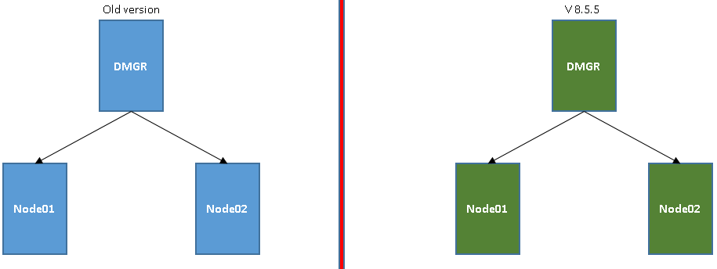  
  You need to create a new cell and populate everything with tools or manually. With this strategy, you don’t need any runtime migration tools.
* In place (replace cell)  
  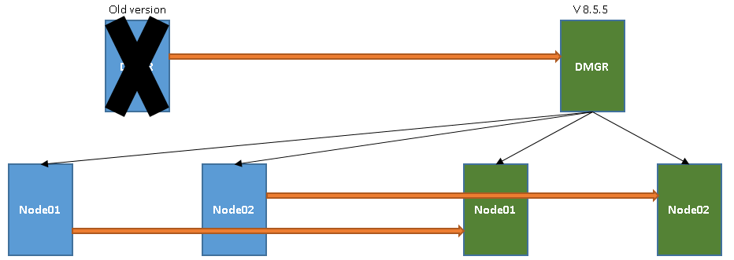  
  You need to re-create existing configuration into a new cell and then migrate DMGR and the nodes.
* In place (replace DMGR)  
    
  Similar to previous strategy, but in this case you add new nodes with newer version to the cells.
* In place (co-exist)  
  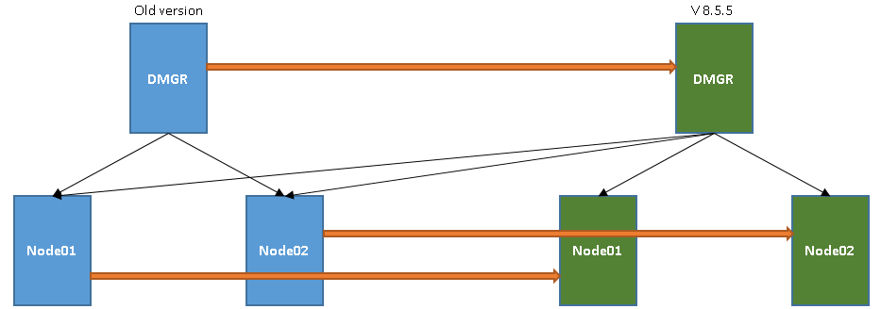  
  You need to duplicate the cell with a newer version with different ports so that both previous and new version exists at the same time.
* Side by side (with intermediate profile)

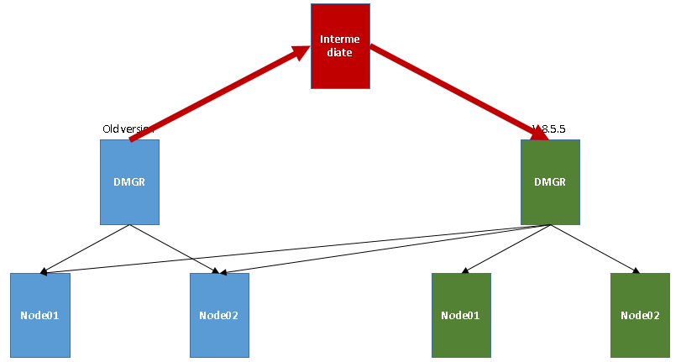  
You need to create a new cell and copy the configurations one by one using an intermediate profile and runtime migration tools.

For all the strategies, you need to have a good plan to perform a successful migration. It’s always better to check the changes of a newer version of WebSphere Application Server and verify the effects of those changes to your applications.

## AIM

In this chapter, you’ll be able to install and work with Eclipse IDE for Java EE Developers tool to work on the applications that will be migrated. Using this tool, you will import an application, check and mitigate potential problems and then export them.

# Lab Exercise 20: MIGRATION

|  |
| --- |
| Install AMT  Import/ Export  Run Analysis |

**1. Install Application Migration Tool**

**2. Import/Export application to migration tool**

**3. Run analysis**

**Task 1: Install Application Migration Tool**

Install AMT

Import/ Export

Run Analysis



**Step 1:** Download latest version of Eclipse IDE for Java EE Developers from <http://www.eclipse.org> compatible with your operating system.

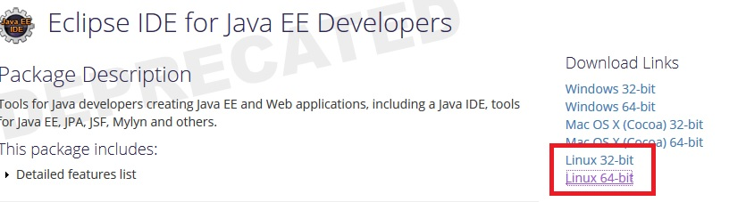

**Step 2:** Downloaded zip file and then extract.

Install AMT

Import/ Export

Run Analysis



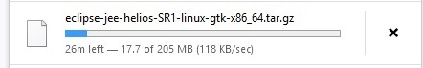

**Step 3:** Double click on eclipse.exe to start the application.

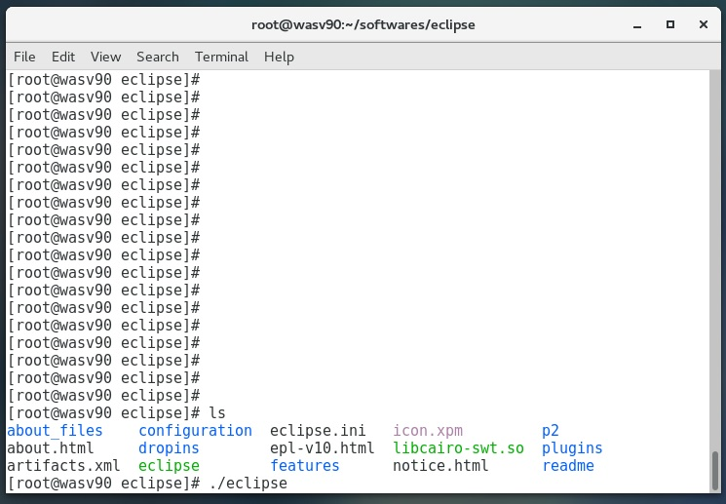

**Step 4:** Run marketplace from “Help>Eclipse Marketplace”.

Install AMT

Import/ Export

Run Analysis



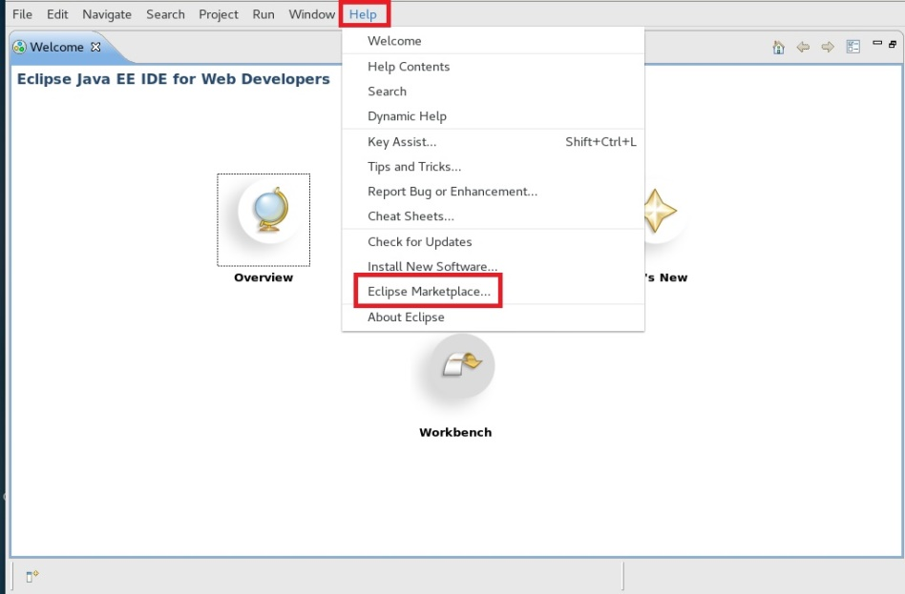

**Step 5:** Search “Websphere migration” and from the results install “IBM WebSphere Application Migration Toolkit”.

Install AMT

Import/ Export

Run Analysis



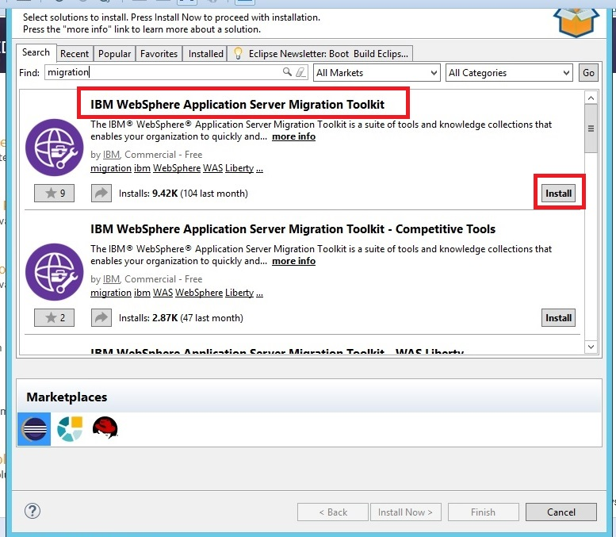

**Step 6:** Select both options and click “Confirm”.

Install AMT

Import/ Export

Run Analysis



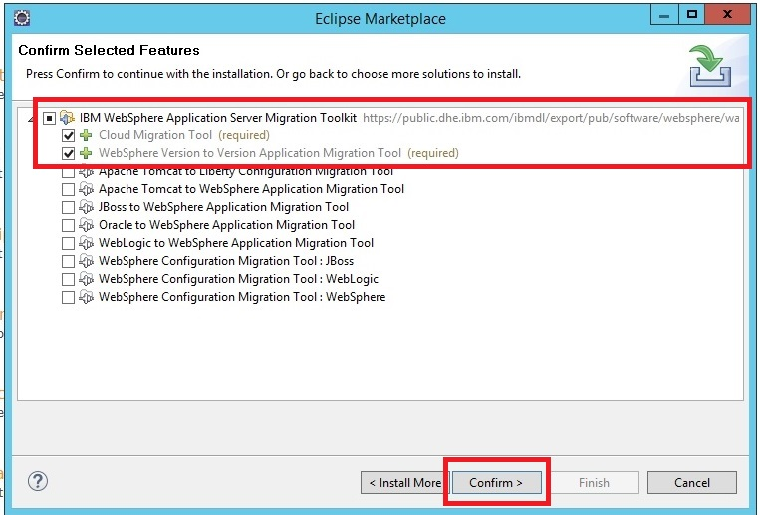

**Step 7:** Click “Finish” to complete installation.

Install AMT

Import/ Export

Run Analysis



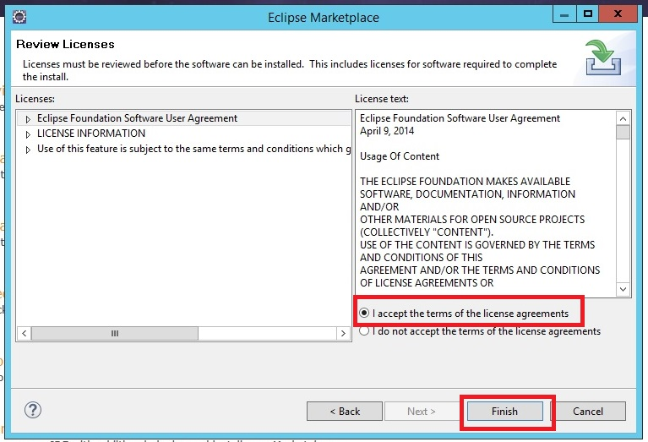

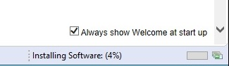

**Task 1 is complete!**

**Task 2: Import/Export application to migration tool**

Install AMT

Import/ Export

Run Analysis



**Step 1:** Start Eclipse and from “File>Import” menu, run import wizard.

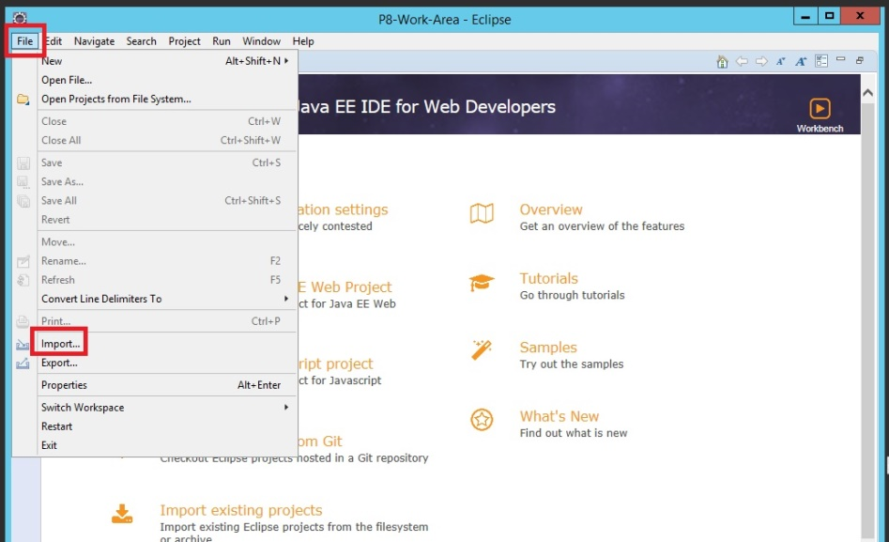

**Step 2:** Under “Java EE” select “EAR file” and click “Next”.

Install AMT

Import/ Export

Run Analysis



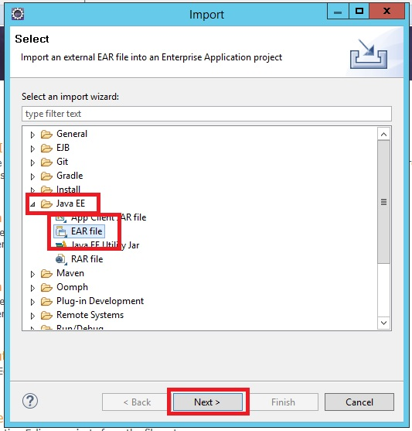  
**Step 3:** Browse the EAR file and click “Finish”.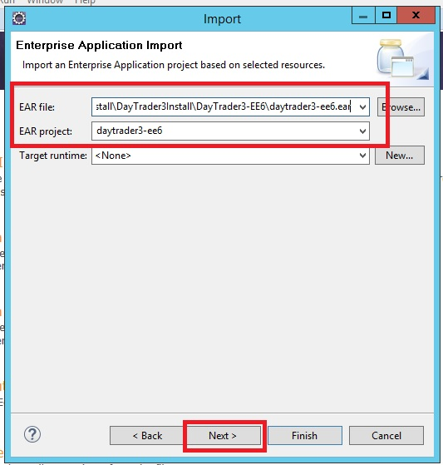

**Step 4:** You can see the details of the application in “Java EE” view.

Install AMT

Import/ Export

Run Analysis



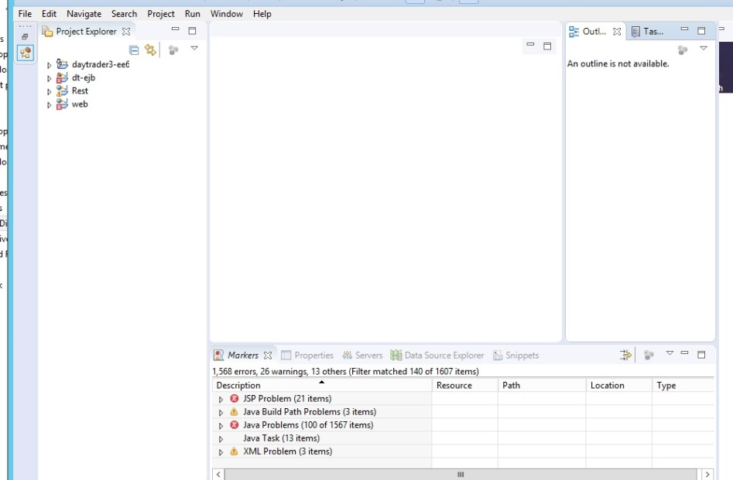

**Step 5:** Select “File>Export> to run export wizard.

Install AMT

Import/ Export

Run Analysis



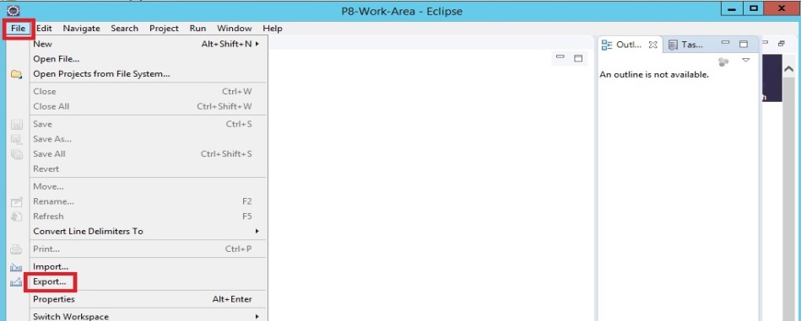  
**Step 6:** Select “Java EE>EAR file” and click “Next”.

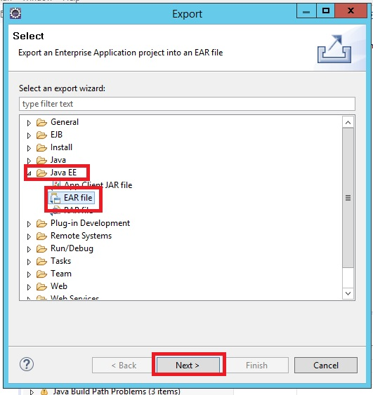

**Step 7:** Select the destination of the files to be exported and click “Finish”.

Install AMT

Import/ Export

Run Analysis



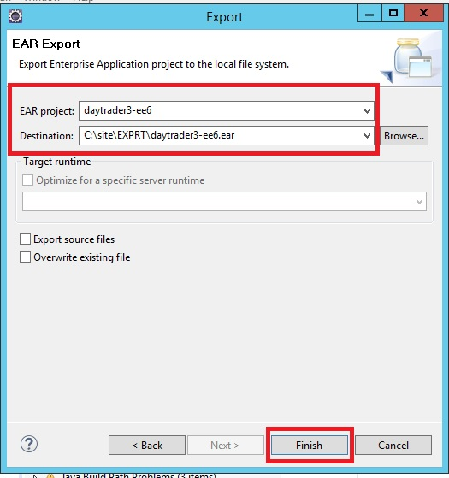

**Task 2 is complete!**

**Task 3: Run Analysis**

Install AMT

Import/ Export

Run Analysis



**Step 1:** Select “Run>Analysis”.

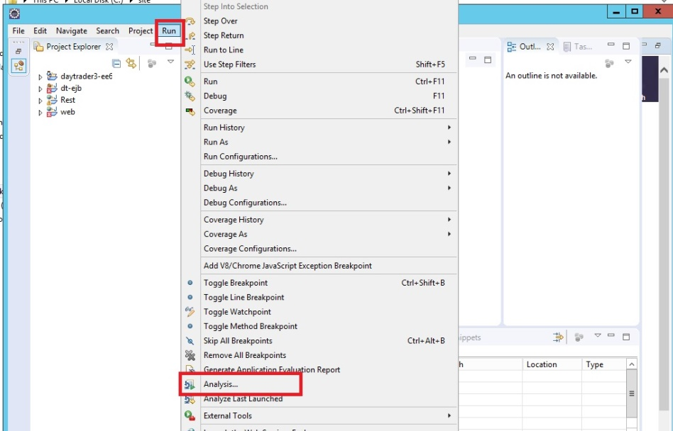

**Step 2:** Select “Run>Analysis”.

Install AMT

Import/ Export

Run Analysis



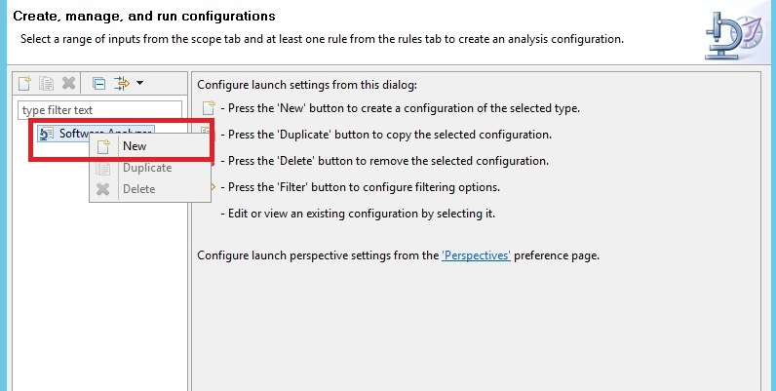

**Step 3:** Update the name and click on “Rules”.

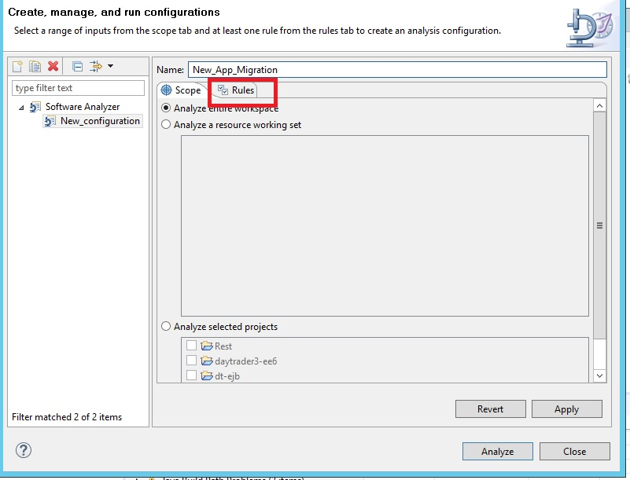

**Step 4:** Select “WebSphere Application Server Version Migration” and then click “Set”.

Install AMT

Import/ Export

Run Analysis



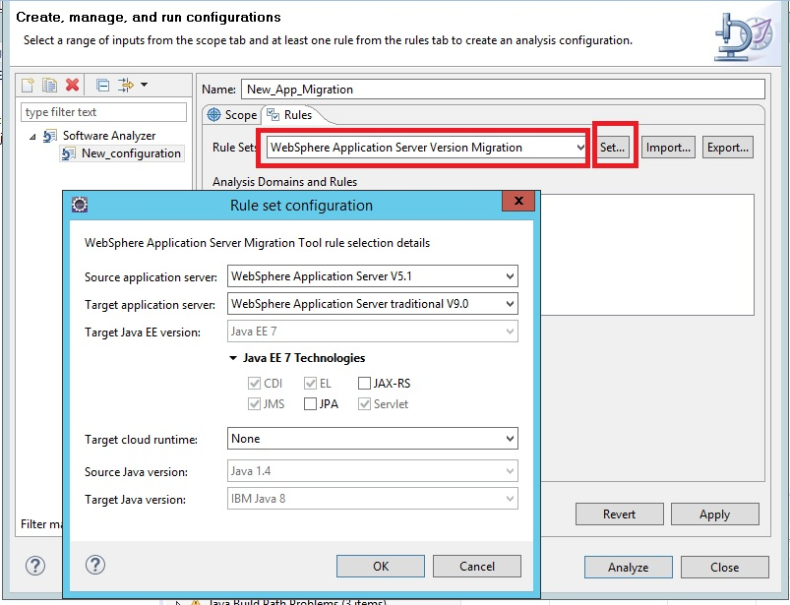  
  
Click “OK” to close the window.

**Step 5:** Click “Analyze”

Install AMT

Import/ Export

Run Analysis



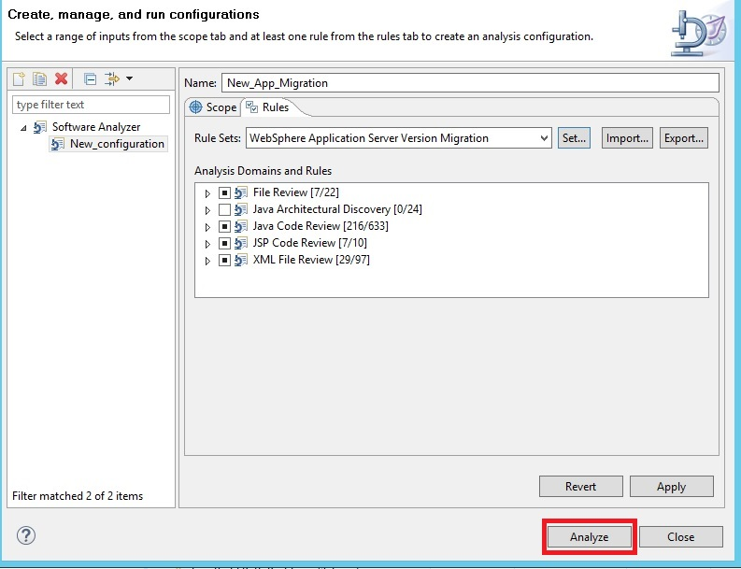.**Step 6:** Right click on the problems and choose “Quick Fix”.

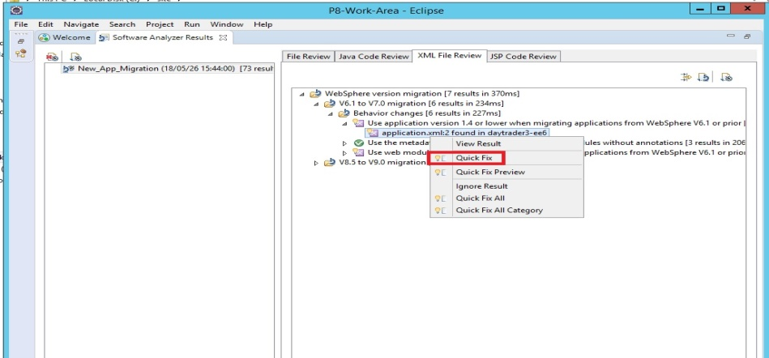

**Step 7:** Repeat Step 6 for the other problems, then you can save and export the application.

Install AMT

Import/ Export

Run Analysis



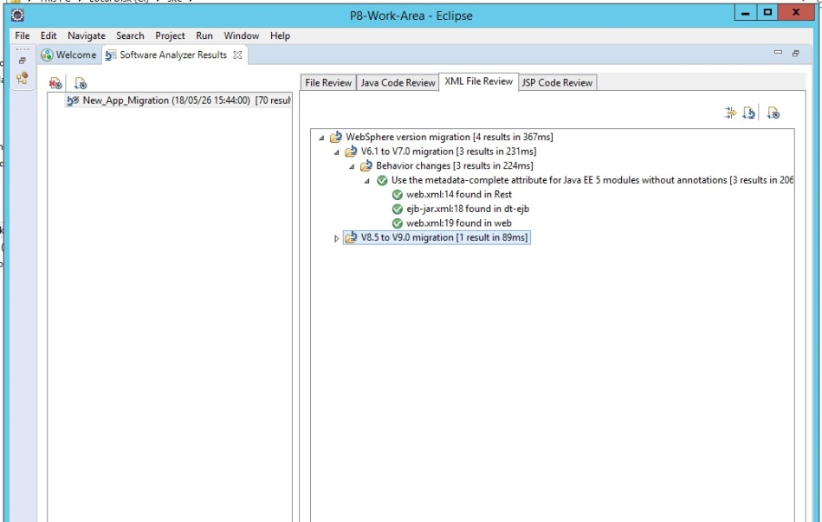

**Task 3 is complete!**

# SUMMARY

Migration, whether from different product or different version of WebSphere Application Server, needs to planned and performed carefully. There are different tools provided for migration activities such as Application Migration Toolkit that helps complex migrations. There are 2 main points to consider during migration planning: application migration and configuration migration. Also there are different approaches for planning and performing migration. Deciding on the correct strategy will depend on your existing environment and requirements.

# REFERENCES

* http://www-01.ibm.com/support/docview.wss?uid=swg27008724
* http://www.ibm.com/developerworks/websphere/downloads/migtoolkit/
* http://www.redbooks.ibm.com/abstracts/sg248048.html?Open
* https://marketplace.eclipse.org/content/ibm-websphere-application-server-migration-toolkit

# INDEX

Application migration 577

Application Migration Tool 577

Configuration migration 577

version to version migrations 577